Author: Chris Bevacqua
Date: 02/20/2026

Grazioso Salvare MongoDB Dashboard

Project Description
This project is a web-based dashboard application developed for Grazioso Salvare that allows users to interact with and visualize data from the Austin Animal Center Outcomes database. The dashboard enables users to filter animals based on rescue type, view the results in a dynamic data table, and visualize the data using charts and a geolocation map.
The application follows the Model-View-Controller (MVC) design pattern:
- Model: MongoDB database storing animal records
- View: Dash dashboard interface (data table, charts, and map)
- Controller: Python code that connects the interface to MongoDB using CRUD operations
The dashboard includes:
- Interactive filter options (Water Rescue, Mountain/Wilderness Rescue, Disaster/Tracking, Reset)
- A dynamic data table
- A geolocation map
- A second chart (pie chart of animal breeds)
- Grazioso Salvare logo
- A unique identifier containing the student’s name

Required Functionality and Proof of Completion
The dashboard provides the following required functionality:
- Displays an unfiltered view of the Austin Animal Center data at startup
- Allows filtering by rescue type:
- Water Rescue
- Mountain or Wilderness Rescue
- Disaster or Individual Tracking
- Reset (returns to unfiltered view)
- Updates the data table dynamically when filters are selected
- Updates the charts dynamically based on the table data
- Displays a geolocation map based on selected table entries
Screenshots demonstrating functionality:
Figure 1: Initial dashboard state (unfiltered)
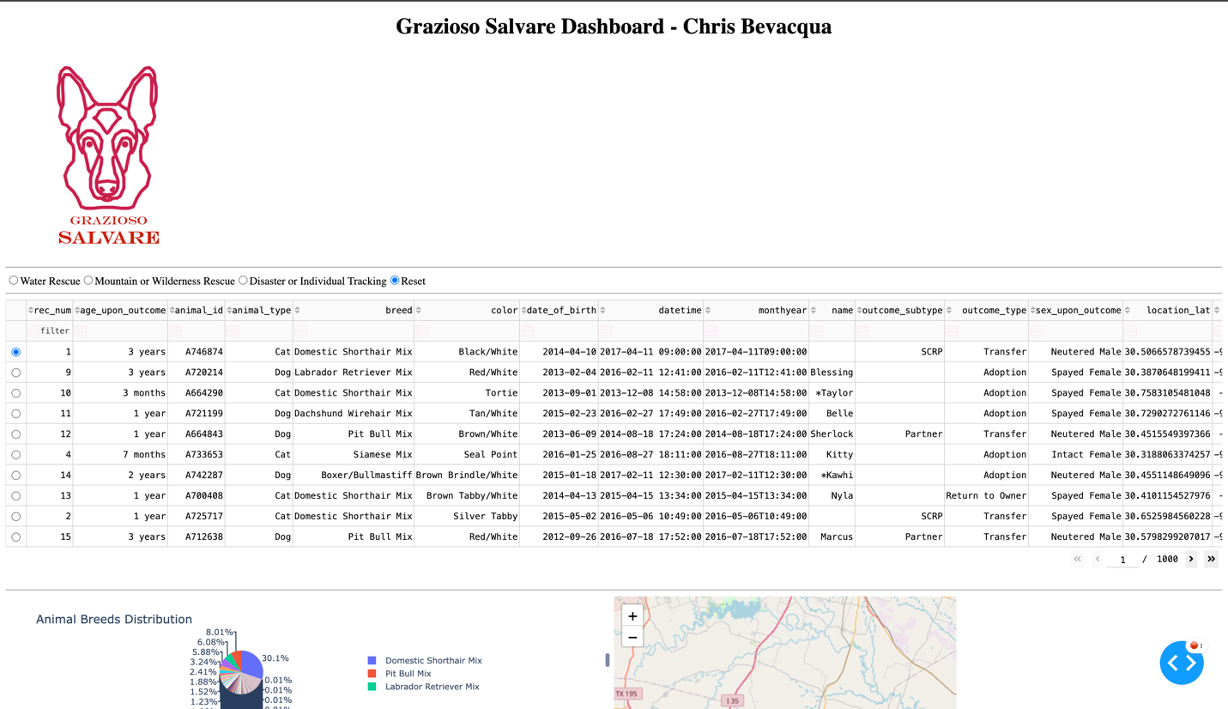
Figure 2: Water Rescue filter applied
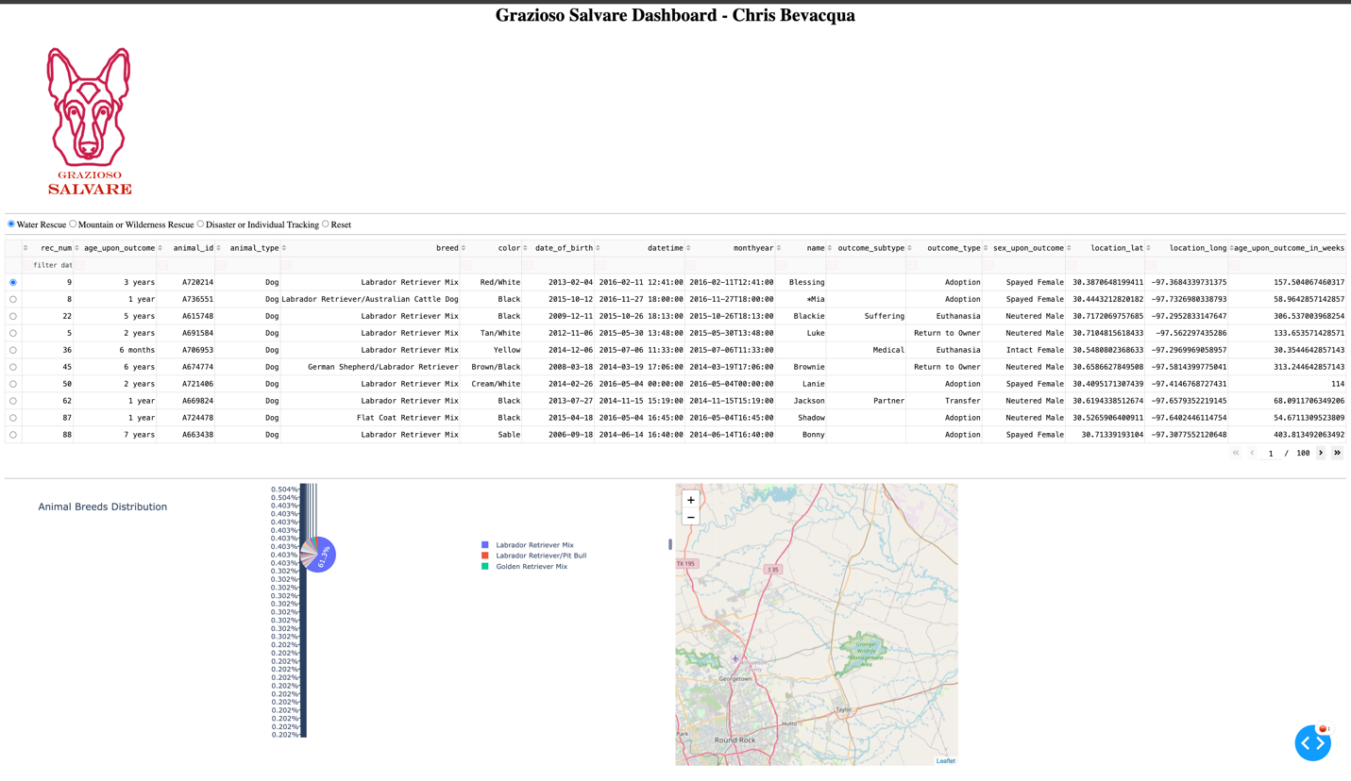
Figure 3: Mountain or Wilderness Rescue filter applied
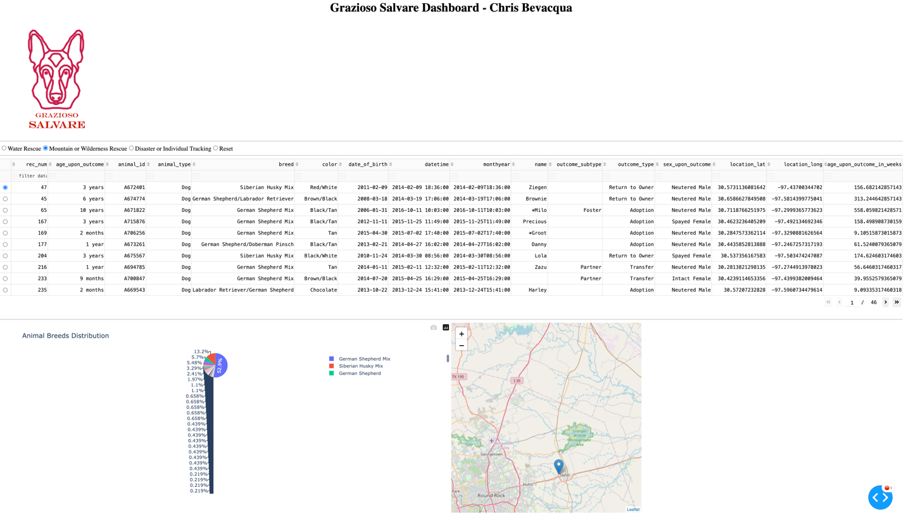
Figure 4: Disaster or Individual Tracking filter applied
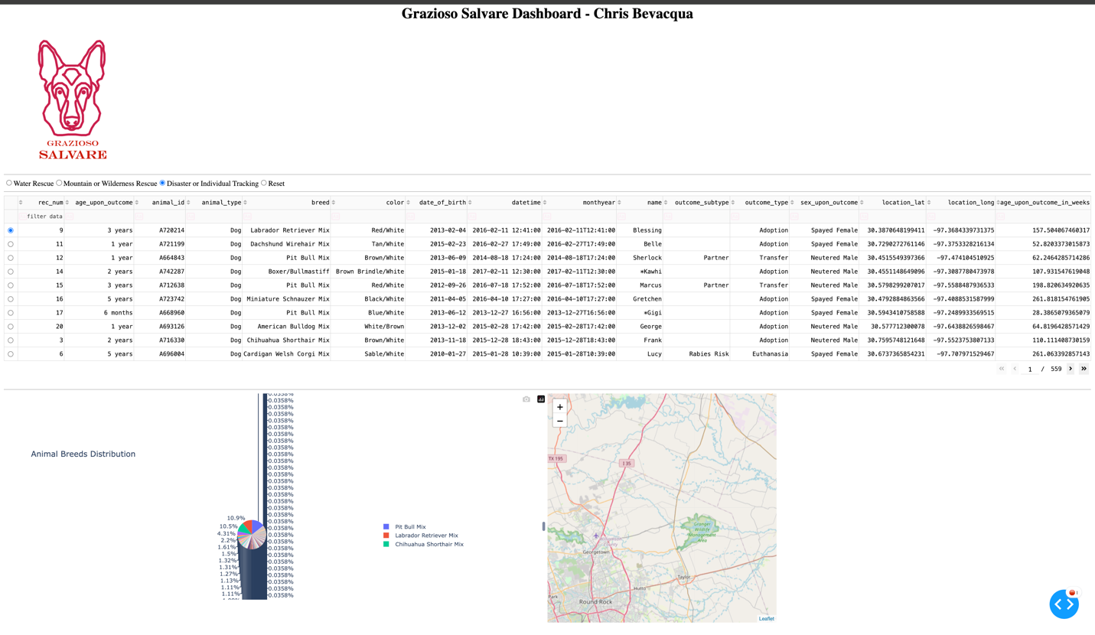
Figure 5: Reset filter applied
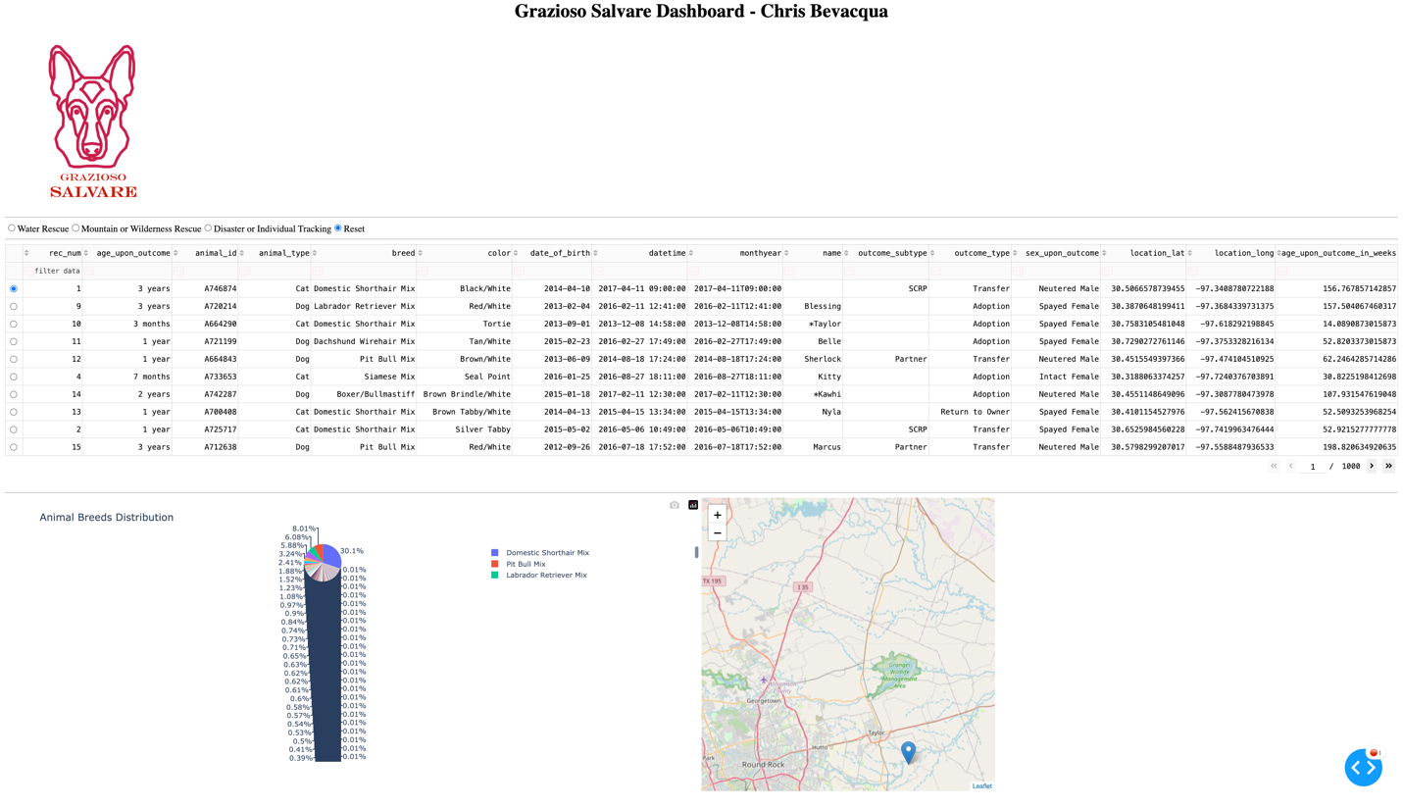
These screenshots demonstrate that all required widgets and filters operate correctly.
Tools Used and Rationale
The following tools were used to complete this project:
- MongoDB: Used as the database model to store animal records
- Python: Used for data processing and dashboard logic
- Dash (Plotly): Used to create the web-based dashboard interface
- Pandas: Used to convert MongoDB query results into tabular form
- Dash Leaflet: Used to generate the geolocation map
- JupyterDash: Used to run the Dash app inside Jupyter Notebook
These tools were selected because they integrate well together and allow real-time interaction between a database and a web interface.

Why MongoDB Was Used
MongoDB was used as the model component of the application because it is a document-based NoSQL database that works naturally with JSON-like data structures. This makes it highly compatible with Python dictionaries and Pandas DataFrames.
MongoDB provides:
- Flexible schema design
- Fast query performance
- Native support for geolocation data
- Easy integration with Python using PyMongo
These qualities make MongoDB well-suited for applications that require frequent filtering and dynamic queries, such as this dashboard.

Dash Framework Explanation
The Dash framework was used to create the view and controller components of the application. Dash allows developers to build interactive web applications using only Python, without requiring HTML or JavaScript.
Dash provides:
- Built-in components for tables, charts, and user input
- Callback functions that automatically update components when data changes
- Integration with Plotly for charting
- Compatibility with Jupyter Notebook
Dash was chosen because it supports dynamic dashboards and is well-suited for data-driven applications.

Resources Used
- MongoDB Documentation
- Dash and Plotly Documentation
- PyMongo Documentation
- Course-provided Dashboard Specifications Document
- JupyterDash Documentation

Project Completion Steps
- Created a MongoDB database and collection containing animal records
- Developed a CRUD Python module to interact with the database
- Created an initial dashboard layout with an unfiltered data table
- Added interactive filtering controls
- Connected filters to MongoDB queries
- Implemented a pie chart and geolocation map
- Integrated Grazioso Salvare logo and student identifier
- Tested all filter options and dashboard components
- Captured screenshots for documentation
- Created README documentation

Challenges and Solutions
Challenge: Displaying MongoDB ObjectId values caused the data table to crash.
Solution: The _id field was removed from the DataFrame before displaying it.
Challenge: Connecting dashboard filters to MongoDB queries.
Solution: Custom queries were implemented in the controller to retrieve only relevant records.
Challenge: Ensuring dynamic updates for charts and maps.
Solution: Dash callback functions were used to update components based on user interaction.

Instructions for Reproducing the Project
- Install required Python packages:
pip install dash jupyter-dash pymongo pandas plotly dash-leaflet
- Ensure MongoDB is running and the aac.animals collection exists.
- Place the following files in the same directory:
- ProjectTwoDashboard.ipynb
- animal_shelter.py
- Grazioso Salvare Logo.png
- Update MongoDB credentials in the code if necessary.
- Run the ProjectTwoDashboard.ipynb file in Jupyter Notebook.
- Use the radio buttons to filter the data and view charts and map updates.

